DBMS PROJECT
By: Izabela Kacanja, Kevin Muho, Hajdi Toto, Desard Lybeshari, Anisa Domi, Ledio Tafciu, Fatime Fejzo

Topic: Student Management System

Project Outline and Planning ( 10%)
- Description
This project is a Student Management System like our system (EIS), for the CEN 203 Database Management Systems course. We will be concentrating on a Student Management System emphasizing the management of student information in an institute using the database knowledge acquired during the course.

In most universities, there is a lot of student data such as personal, course enrollment, grades, and department data that needs to be stored and retrieved on a regular basis. Storing and managing such data without a carefully planned database would result in many problems, including repeated entry of data, inaccuracies, and slow retrieval of data. The objective of our project is to learn how a database will be able to rectify all such problems.

- Core Idea of the Project
The database will be managing and storing the information of students, courses & faculty and various departments as well as enrollment activities and files. It would allow the admin to keep track of total number of students, registrations in the course,date and time. This method will support data integrity and access to information optimality in our database.
In this project, we will model the system using Entity Relationship Diagrams (ERD) and translate the design into a relational schema. SQL is the database that will be used, tables will be created and loaded with some data. A further technical writing of some managerial queries to obtain information such as the student population, course’s details and performance is required.

- Project Planning and Steps
- Requirements Analysis
- Entity-Relationship Diagram (ERD) Design
- Relational Schema (RS) Creation
- Normalization and Optimization
- Database Implementation Using SQL
- Managerial and Academic Queries
- Testing

- Expected outcome
In practical terms, the expected output of the proposed project is that it may help develop an organized and efficient database of the “Students Management System.” It would be capable of managing the information regarding the students and the courses as well as the enrollment, and it would be able to answer the queries regarding different decisions made.

- Expected functionalities:
- Store and manage student personal and academic information.
- Organize departments, programs, and the courses offered.
- Enable students to enroll in more than one course per semester.
- Track course enrollments and their status.
- Manage semester information.
- Record grades of students for every enrolled course.
- Be able to support multiple assessment components, such as midterms, finals, quizzes, and projects.
- Maintaining course schedules including day, time, and classroom.
- Ensure data integrity by using primary and foreign key constraints.
- Avoid data redundancy by properly structuring the relationships among entities.
- Provide access to student academic records, as well as course information.

- Assumptions:
- A student can be enrolled in only one program at a time
- A course belongs to one program only
- Each enrollment occurs in one semester
- Each enrollment produces one final grade
- Courses may have multiple schedules
- Assessment components like quizzes and projects are optional
- One lecturer is assigned per course

- Improvement concept
For our improvement proposal, we will work with the implementation of normalization. By using the concept of normalization, it ensures that the database design becomes more and more efficient, effective, and manageable. The term normalization can be explained in terms of understanding data in relation to the database table in an organized manner, with the help of which each and every part of data, in relation to attributes, has relied on proper keys in relation to the primary key. By using the process of normalization, it avoids redundancy and data has been organized in relation to tables, which are rational and in relation to attributes, and relied upon proper keys in relation to their primary keys in relation to 1NF, 2NF, and 3NF.

Two normalizations will be done. 1NF in the grade relation and 3NF in course relation:

In grade relation the attribute evaluation has multiple values making the table NOT in 1NF. In order to normalize it to 1NF evaluation needs to be separated into different attributes, that is why we created 3 different attributes and removed evaluation. Those attributes are: Grading component, Points and Percentage. So now we can say that that Grade relation is in 1NF
Below is shown how the grade relation (NOT in 1NF) would look like with data in it, emphasizing the multiple values in the evaluation column.
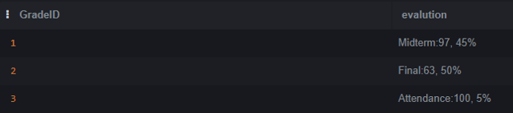

We then move on to 3NF.For a table to be in 3NF, it should be in 2NF first,but in our case, the relations are automatically in 2NF since all relations are made up of single column primary keys, leaving no possibility for partial functional dependencies. In the Course relation, the table is not normalized in 3NF because we have transitive functional dependency, meaning a nonkey column determines another/other nonkey column/columns.The ones that created transitive dependency is Program Name->Department Name. We created other relations in order to not have this type of dependency anymore and to normalize the relation to 3NF.
We created 2 tables/relations, Program and Department which made the normalization to 3NF possible. Now the ERD and the relational schema are normalized twice. Once in 1NF in the Grade relation and the second time normalized to 3NF in the Course relation.

- ERD AND RELATIONAL SCHEMA before and after normalization in 1NF and 3NF
Before:
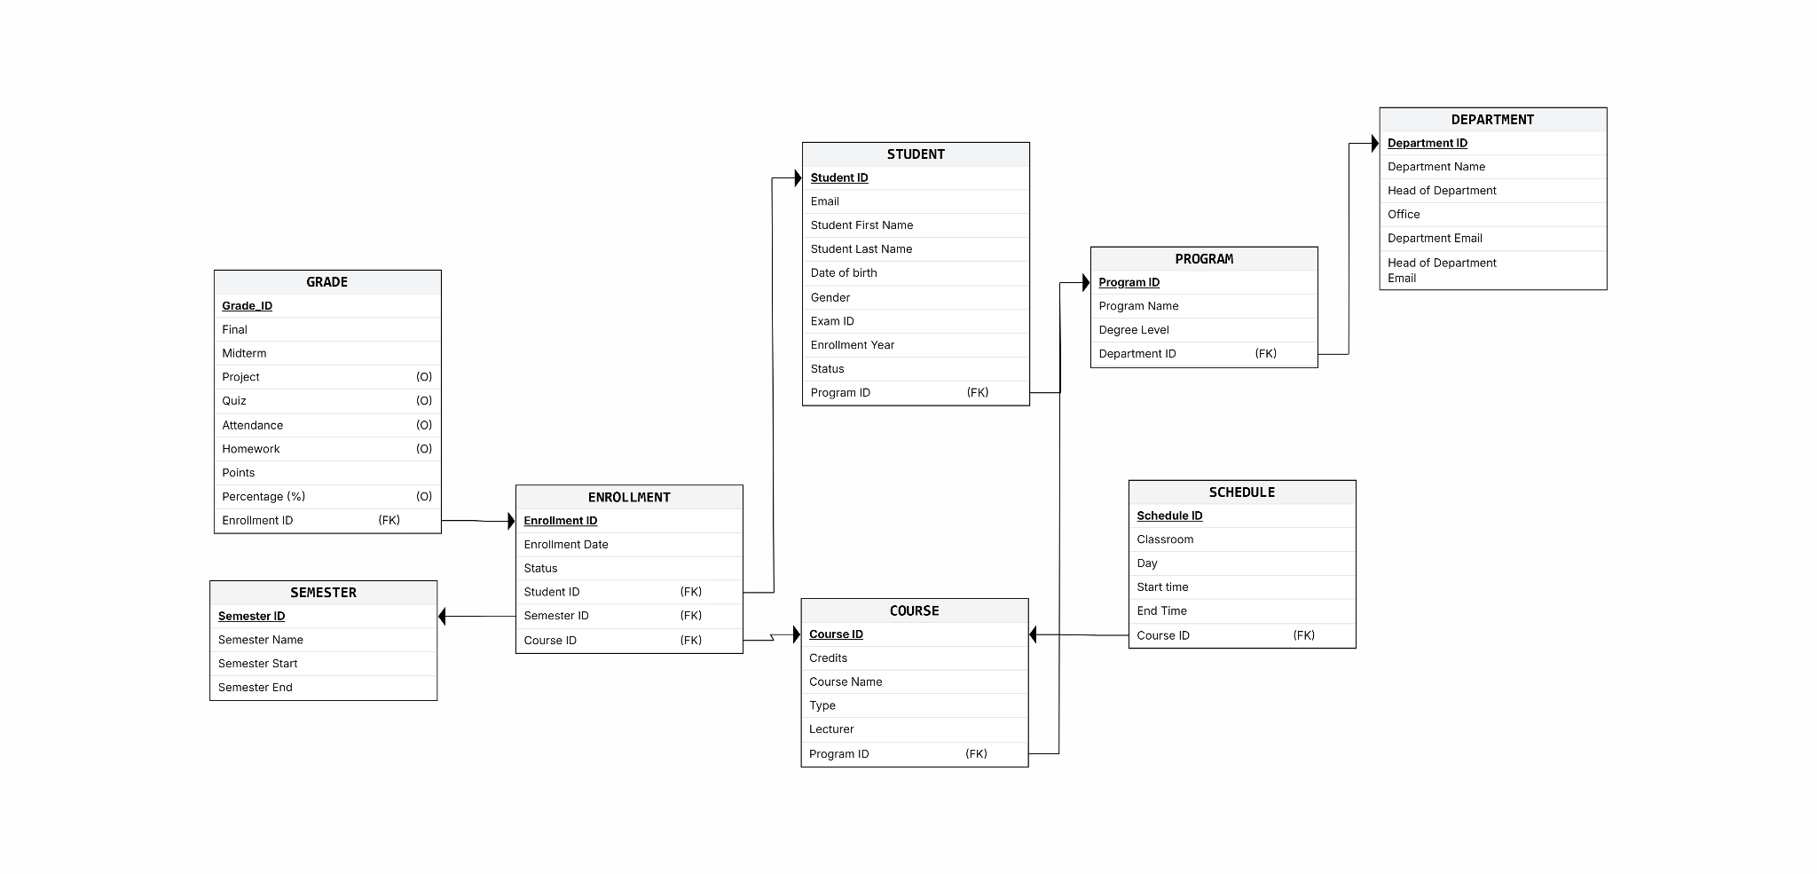
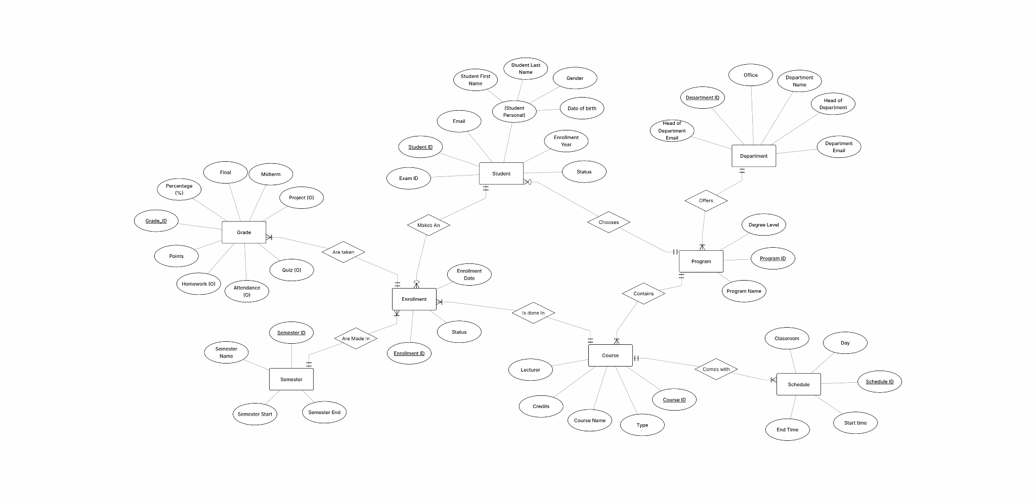
After:
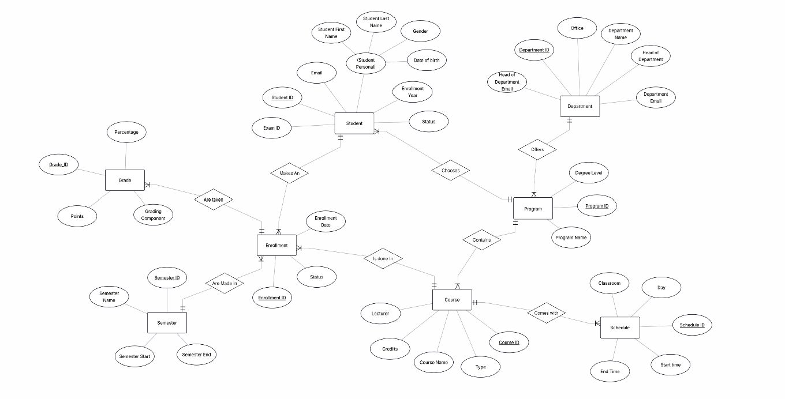
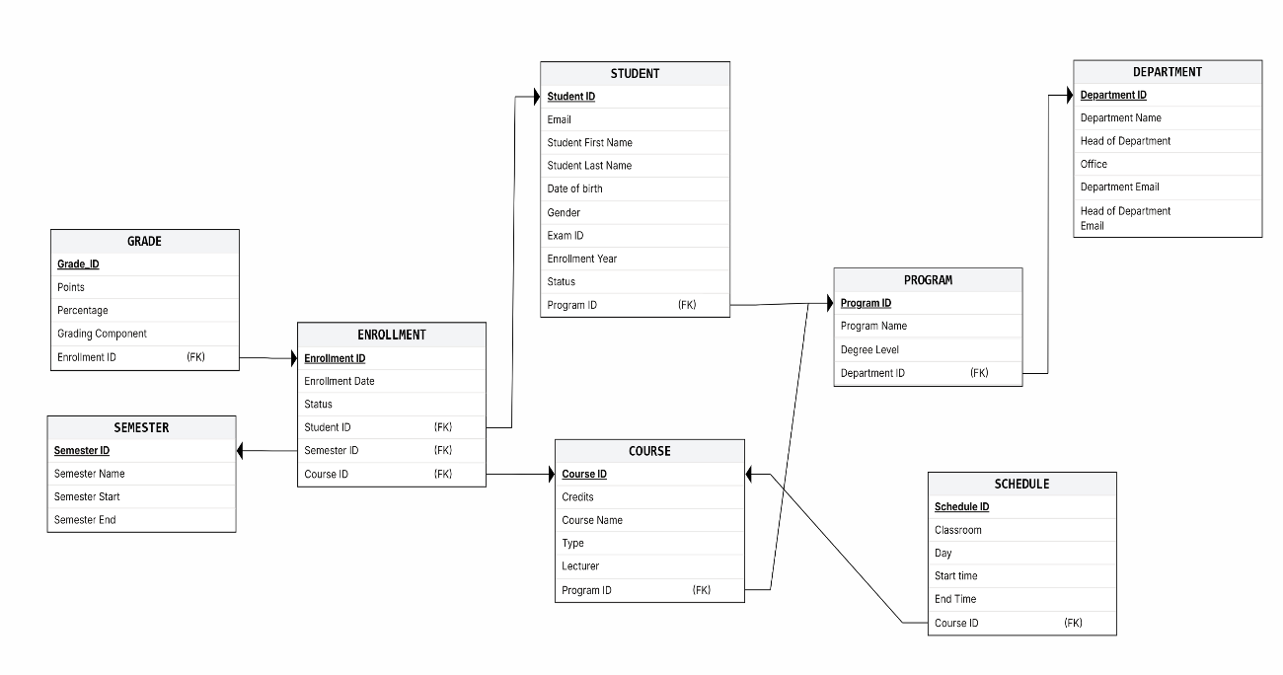
Entities in the ER diagram represent real-world entities such as students and courses .At the relational level, each entity is represented by a table in the database. The primary keys in a table aid in the uniqueness of the records and prevent any form of duplication of information.
- Each entity → one table
- Each attribute → one column
- Each table contains a Primary Key field which serves as an identifier.

- Entity Reasoning
- Enrollment is for:
  - Resolve the many-to-many association between Student and Course
  - Store enrollment specific data such as ‘status’, ‘date’, and ‘
- Grade separated to:
  - Store multiple assessment components (midterm, final, quiz)
  - Maintain independence for grading over enrollment logic

- For there to be scheduling,
  - A course can be offered at various times, days, or rooms
  - Data regarding the schedule should not be duplicated inside the Course entity

- Handling relationships
- (1-M) This signifies a One to Many relationship, where data of one table can be matched to data of more than one record of another table. This assists in linking students to their department without repeating the details of the department.
  - Solution: Foreign keys are placed in the table on the ‘many’ side.
  - One Department →many Students
  - The department_id column in the STUDENT table contains a foreign key.
  - M-N Many-to-many relationships cannot be directly represented in relational databases
    - Solution: We created a junction (bridge) table
    - Students <->Courses
    - Solved using the ENROLLMENT table:(student_id , course_id (FK), Additional attributes like grade, semester)

- Importance of junction tables

A junction table is the table used in resolving the many-to-many (M-N) relationship between entities in a database. In fact, M-N relationships between entities in relational databases are not supported. A junction table, therefore, has to be used.
- Reduces data redundancy by avoiding repeated values in multiple tables
- Supports database normalization, ensuring compliance with First Normal Form (1NF) and higher normal forms
- Ensures data integrity and consistency through the use of foreign keys
- Facilitates accurate representation of real-world relationships, such as students enrolling in multiple courses
- Stores relationship-specific data that does not belong to either entity alone (e.g., grades, enrollment dates, semesters)
- Improves scalability and flexibility, making it easier to add new relationships or attributes without redesigning existing tables

- Design choices

The database is developed to represent the data pertaining to the students in an efficient way. The database design encompasses concepts like the relational database.

Organization. Each major idea (Student, Course, Department) has its own tables organized in such a way that no data repetition occurs.

The values of the primary key are utilized for the identification of rows, whereas, on the other hand, the values of the foreign key are utilized for constructing relationships between tables.

Relations involving multiple records on both sides, such as multiple students enrolling in multiple courses, are implemented through junction tables (for example, the Enrollment table).

Normalization: The given RDBMS schema is in 3NF.

This ensures that:

- Data is stored only once
- Redundancy is minimized
- Update, insertion, and deletion anomalies are prevented
- Data integrity and consistency are maintained

- SQL files and queries

To implement our student system database, we used MySQL Server and MySQL Workbench.At first we created a database on the server and after ensuring it exists with “SHOW DATABASES;” we then located it on the workbench. We then started by creating a CREATE TABLE for each of our entities relating to our ERD and RS after normalization. Then we inserted all of our sample data with examples from our EPOKA system. After that we started on the 20 managerial queries which we thought would be most used in a student system by an admin. Here is two snippets of some of our create and insert tables:
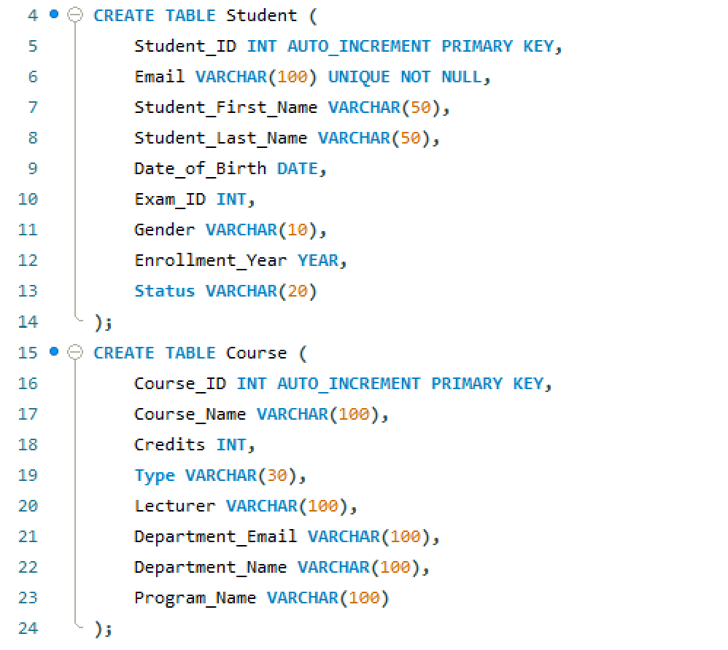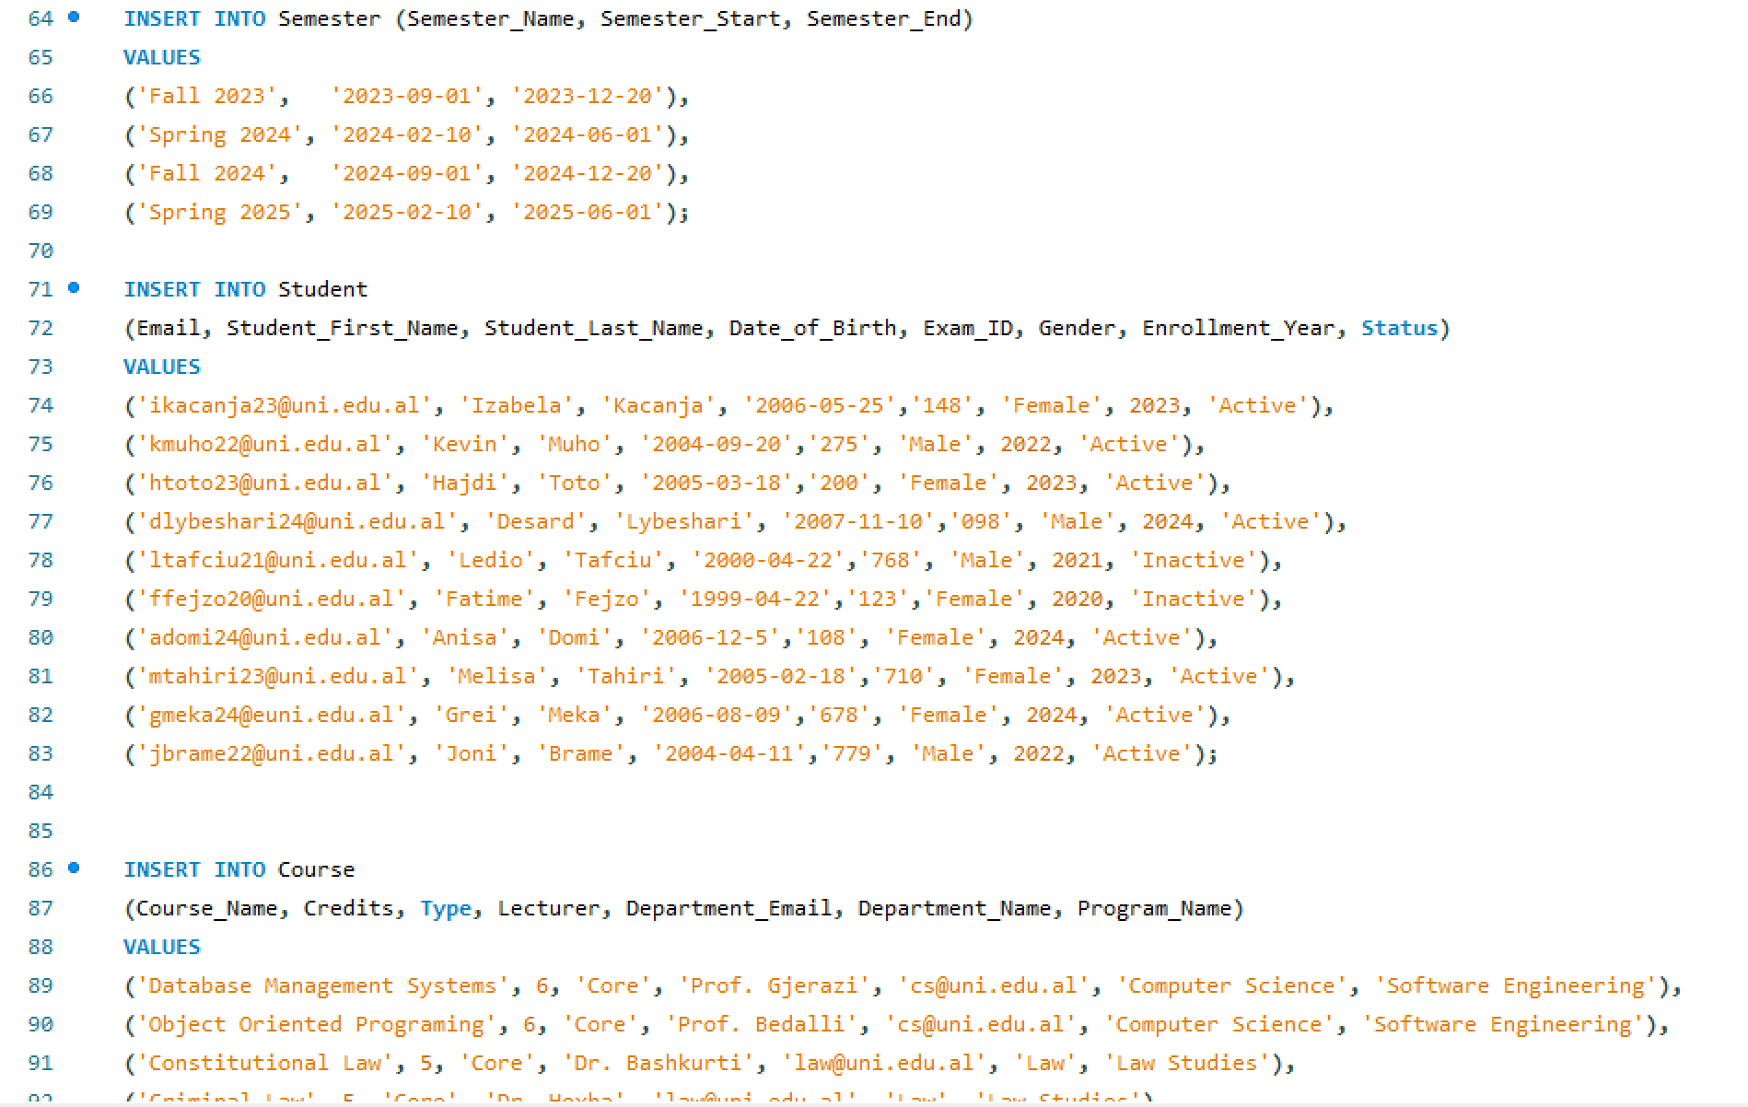
Managerial Queries
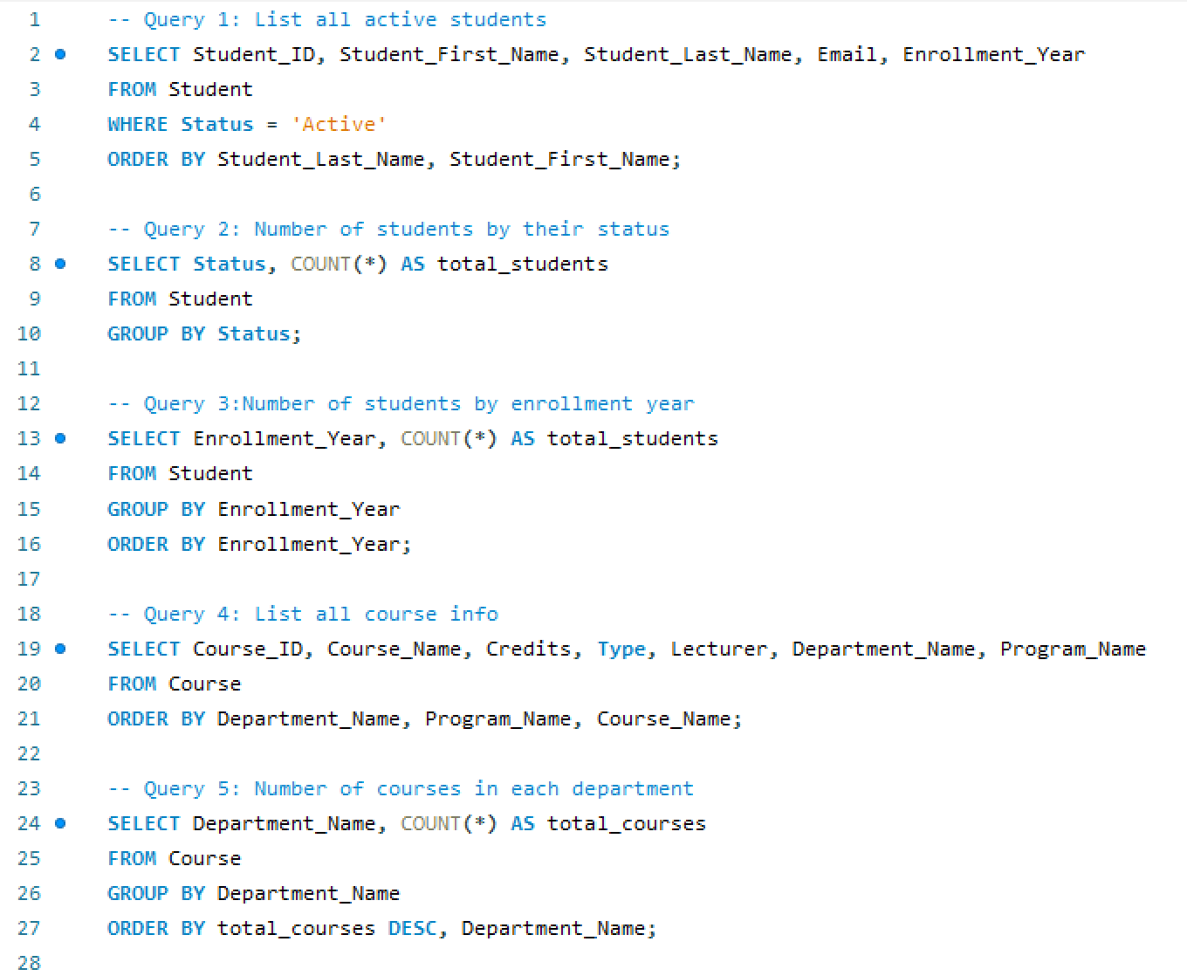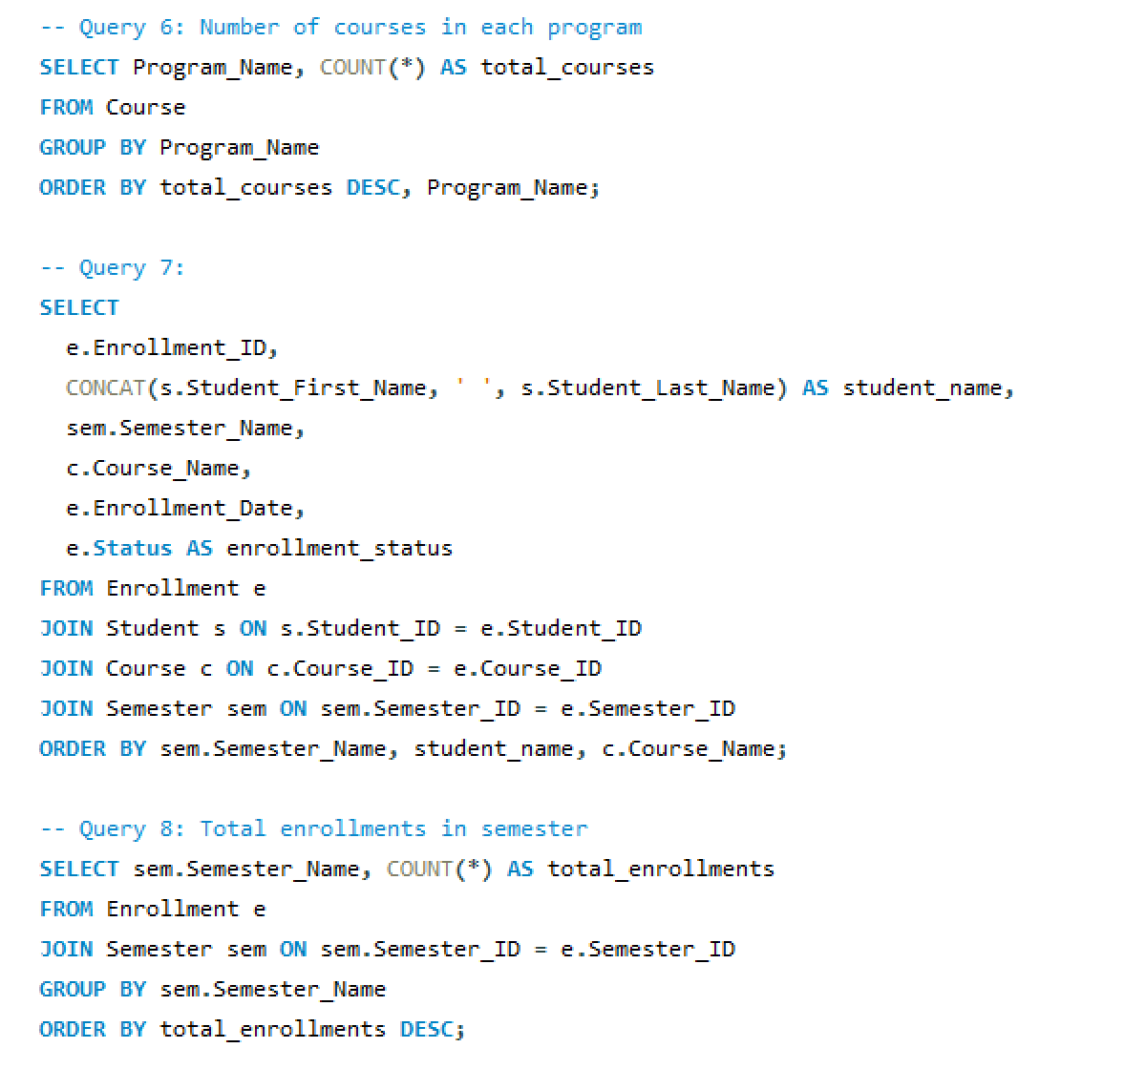
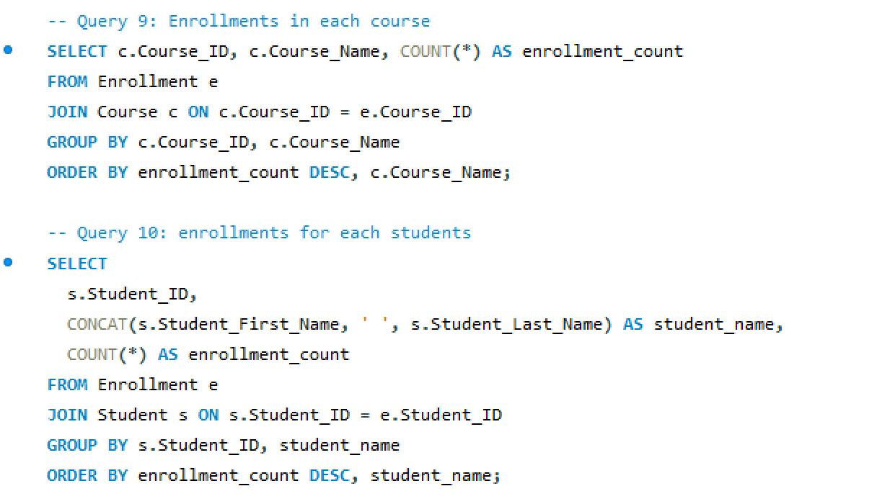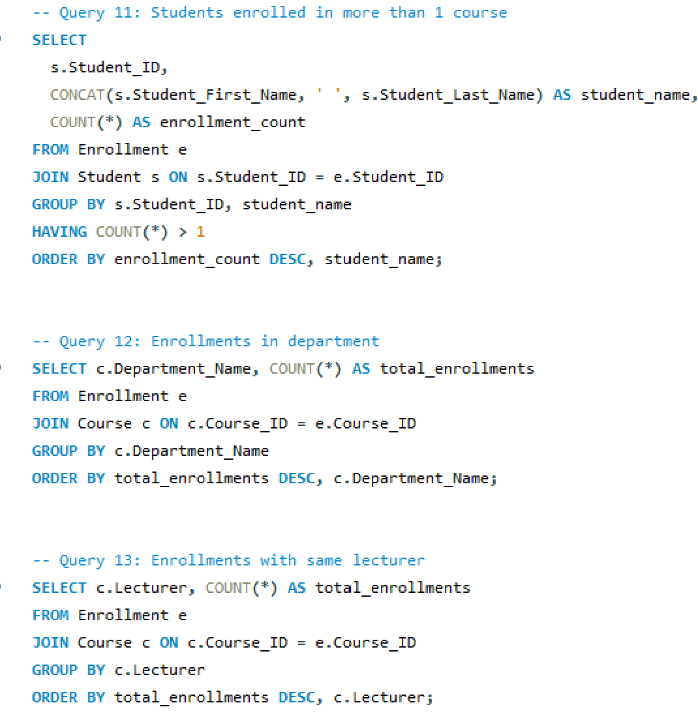
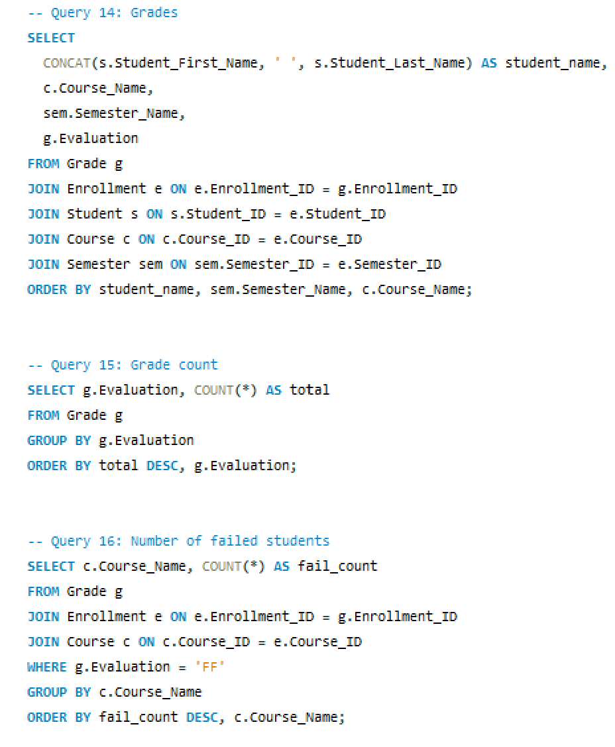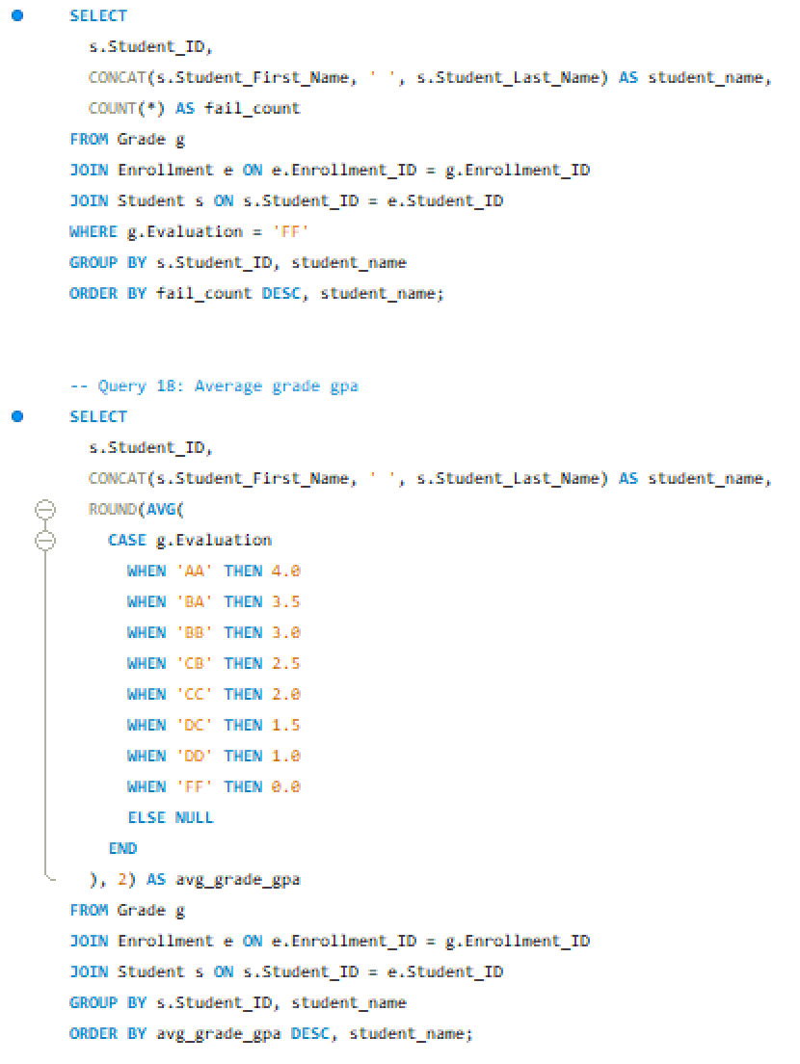
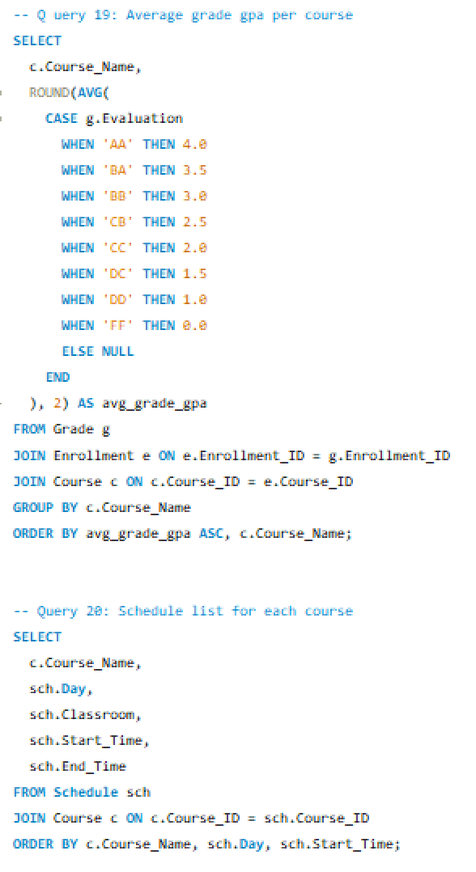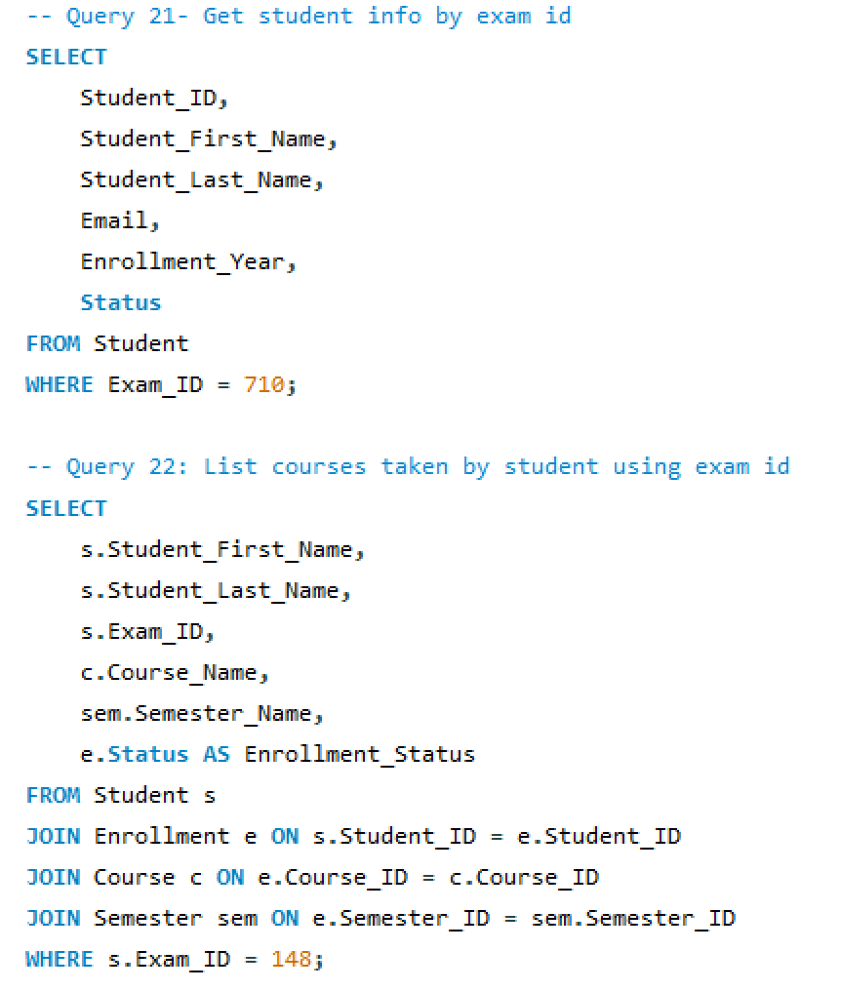
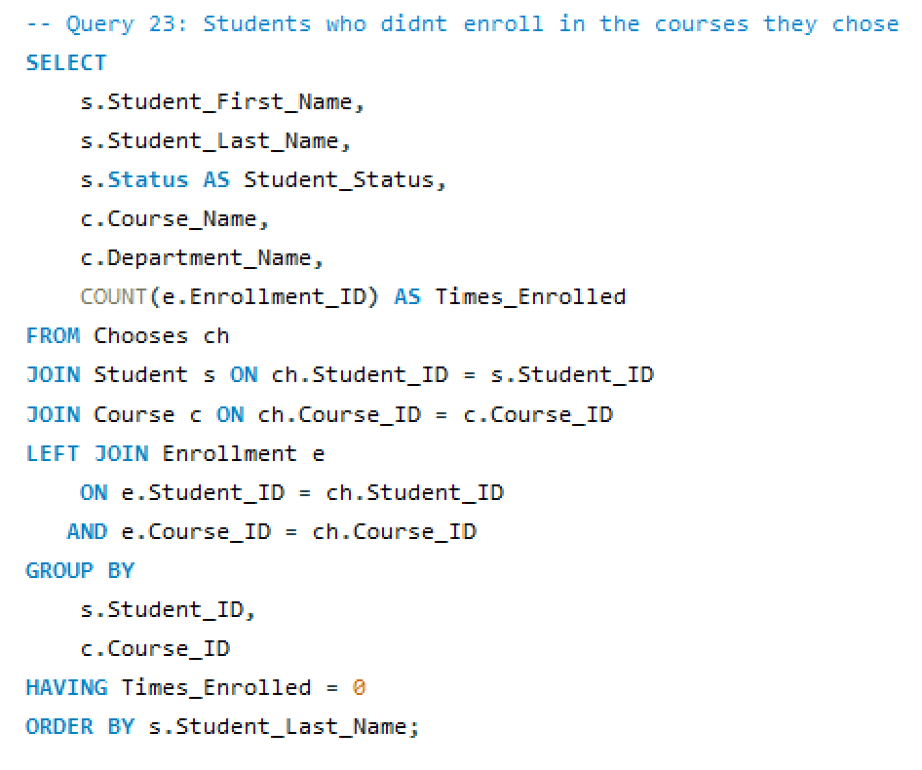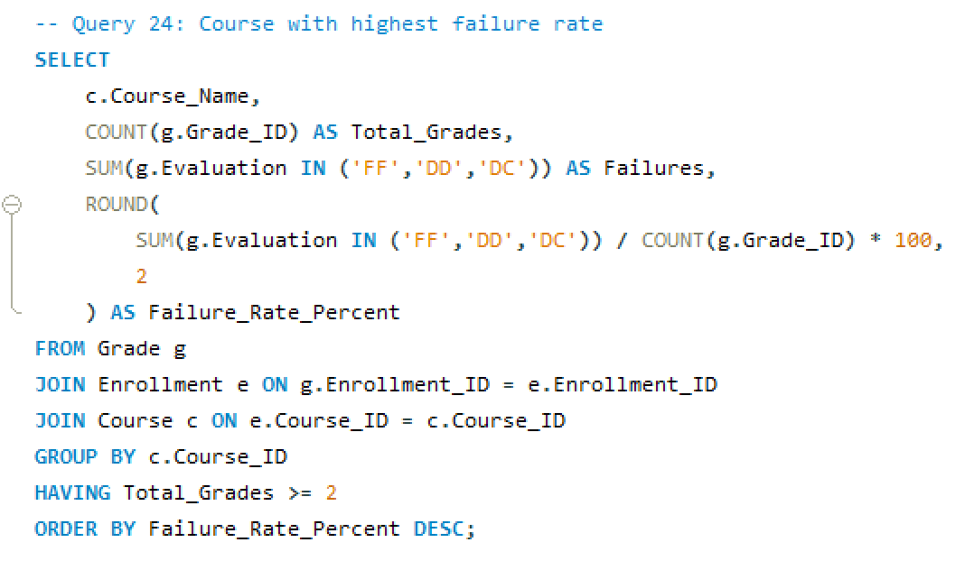

- Limitations & future improvement
The limitation with this project is that it only requires a small amount of data, which doesn't reflect actual data, particularly large data. Also, it's limited to simple queries in SQL, which does not involve really complex SQL like stored procedures, triggers, or user security privileges.
In addition this environment is contained, which does not link it with the actual application interface. Looking forward, it can be expanded by adding data, some complex capabilities in SQL, or by incorporating this database with an application, whether website based or desktop based. Security privileges for the user can be added too.

- Conclusion
This team project helped us to understand in which manner a properly designed relational database can be used to efficiently store and manage data of students. This project offered us the opportunity to demonstrate the functionality of databases in decision making through effective data retrieval by conceptualizing tables, importing data, and crafting managerial SQL queries. SQL queries were important to us in analysing data related to student performance tracking and answering certain managerial level questions. Above all, it perfectly reinforced our understanding of a properly designed database, SQL syntax, and the importance of databases to manage large amounts of data.

